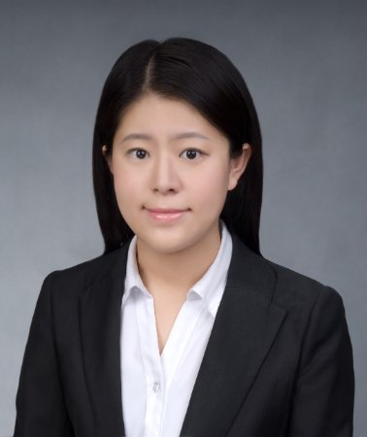
题 目：Modeling Efficient Inbound Logistics Systems vis Capacitated Clustering

报告人：董智捷博士

时 间：2017年4月18日（星期二）

15:00-17:00
地 点：江宁校区经管学院办公楼702室

讲座内容：
Logistics is a vitally important part of the economy, and logistics costs account for about eight percent of the United States’ GDP. How to design efficient inbound logistics systems has economic significance as well as other benefits to the community. The focus of this talk is on two capacitated clustering based optimization models which are proposed for the efficient design of routes and schedules for moving materials into manufacturing or assembly plants. One model considers pick-up frequency and spatial design as joint decisions to minimize total logistics (transportation plus inventory) cost, and the other includes opportunities for split pick-ups at suppliers as a way of partially buffering the uncertainty in the load quantities and also incorporates controls (either penalties or constraints) designed to improve the “regularity” of service to individual suppliers.
报告人简介：
董智捷博士，目前担任美国德州州立大学工业工程系助理教授，曾任美国联邦快递公司担任高级运筹研究员。她于2015年在康奈尔大学获得交通系统工程博士，2012年在哥伦比亚大学获得工程项目管理硕士，2011年在南京大学获得工学学士。她的主要研究兴趣是开发用于管理复杂系统的数学模型和解决方法，包括交通运输和物流系统，民用基础设施网络和项目网络。她的研究已经在各种国际会议上展示，并发表在包括Transportation Research Part E在内的著名国际期刊。同时，担任包括Transportation Research Part E和Journal of Computers and Industrial Engineering在内的多个重要期刊的审稿人，并获得World Conference on Transport Research Society授予的Young Researchers Initiative Award的。
主办单位：经济与管理学院工业工程研究所

