温坤礼教授学术报告

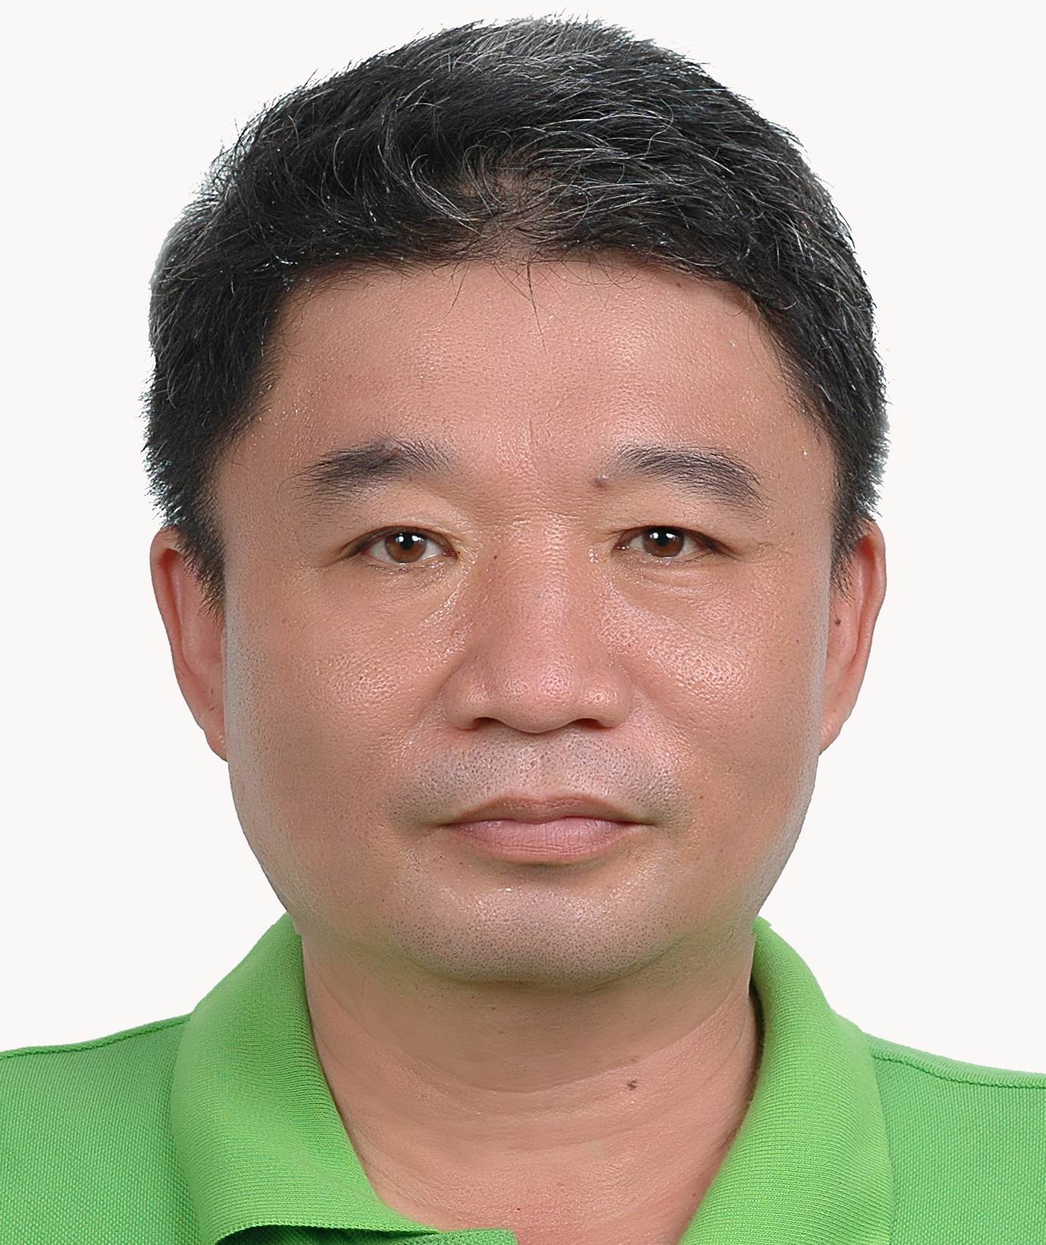
演讲人：建国科技大学教授 温坤礼
演讲题目：The Completeness of Grey Relational
Analysis and the Development of Computer Toolbox
时间：2017年4月21日（星期五）上午9：30
地点：南航将军路校区 经济与管理学院楼704

附：温坤礼教授简介
Kun-Li Wen received his B. S. degree in E.E. and M. S. degree in Automation Engineering from Fengchia University, Taichung, Taiwan in 1980 and 1983 respectively. In 1997, he received the Ph. D. degree in Mechanical Engineering from National Central University, Chungli, Taiwan. He is currently full professor in Department of Electrical Engineering, Chienkuo Technology University. The academic aspects are technology committee on Grey System SMC society (2008~), dean of the Research, Taichung Chapter, IEEE SMC Society (2009~), chief editor of Journal of Grey System (Taiwan), editorial board of Journal of Convergence Information Technology (South Korea), editorial board of Grey System Theory and Application (England), editorial board of Advances in Fuzzy Sets and Systems (USA), editorial board of International Journal of Kansei Information (Taiwan). General Secretary of Taiwan Kansei Information Association, visiting scholar in Energy Systems Research Center, University of Arlington, Taxes, USA. His research interests are grey system analysis, rough set theory and kansei engineering. Over the past seven years, more than 10 research projects have been completed, including the Ministry of Science and Technology, the Ministry of Education and the Hakka Affairs Council, published 5 academic books, 27 journal papers, 34 international conference paper, 6 inventions and new patents. The award includes silver medal in 2011 Italian Invention Award; silver medal in 2011 Polish Invention Award; bronze medal in 2011 South Korea Invention; bronze medal in 2012 Paris, France Invention Award; gold medal in 2012 Malaysia Invention Award; gold medal in 2013 Pittsburgh Invention Award; gold medal in 2013 Macau Invention Award and silver medal in 2016 Hong Kong Innovation and Technology International Invention Exhibition.

主办单位：灰色系统研究所

